**APERCU**

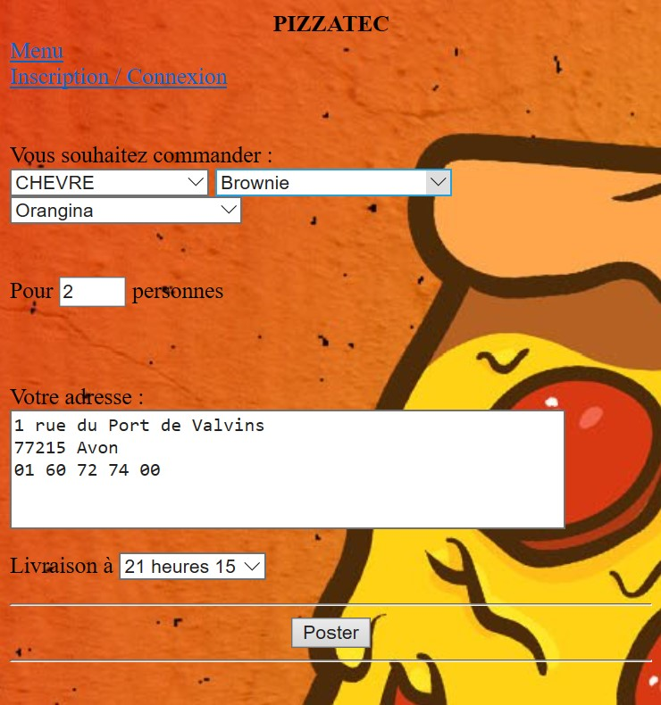

**LE CODE**

<HTML>

<HEAD>

<TITLE>

Votre Commande - PIZZATEC

</TITLE>

</HEAD>

<FORM name="bondecommande"action="finish.php"method="post">

<CENTER><B>PIZZATEC</B></CENTER>

<?php

echo"<br><a href='menu.php'>Menu</a>";

echo"<br><a href='login.html'>Inscription / Connexion</a>";

?>

<BODY style="background: url('b.jpg');">

<meta charset="utf-8">

<BR></BR>

<BR>Vous souhaitez commander : </BR>

<SELECT name="nourriture">

<OPTION value="pnull"> --CHOISIR PIZZA--

<OPTION value="MARGUERITA"> MARGUERITA

<OPTION value="REGINA"> REGINA

<OPTION value="CAMPIONE"> CAMPIONE

<OPTION value="CHEVRE"> CHEVRE

<OPTION value="4_FROMAGES"> 4 FROMAGES

<OPTION value="VEGE"> VEGE

<OPTION value="NEPTUNE"> NEPTUNE

<OPTION value="BOURSIN"> BOURSIN

<OPTION value="CHICKEN"> CHICKEN

<OPTION value="SUPREME"> SUPREME

<OPTION value="Sans_plat"> Sans plat

</SELECT>

<SELECT name="dessert">

<OPTION value="dnull"> --CHOISIR DESSERT--

<OPTION value="Brownie"> Brownie

<OPTION value="Glace"> Glace

<OPTION value="Ban_Nut"> BanNut

<OPTION value="Muffin"> Muffin au chocolat

<OPTION value="Sans_dessert"> Sans dessert

</SELECT>

<SELECT name="boisson">

<OPTION value="bnull"> --CHOISIR BOISSON--

<OPTION value="Coca_Cola"> Coca-Cola

<OPTION value="Pepsi"> Pepsi

<OPTION value="Fanta"> Fanta

<OPTION value="Sprite"> Sprite

<OPTION value="Orangina"> Orangina

<OPTION value="7UP"> 7UP

<OPTION value="Vin_Rose"> Vin Rose

<OPTION value="Vin_Rouge"> Vin Rouge

<OPTION value="Vin_Blanc"> Vin Blanc

<OPTION value="Eau_de_source"> Eau de source

<OPTION value="Heineken"> Heineken

<OPTION value="Chouffe"> Chouffe

<OPTION value="Desperados"> Desperados

<OPTION value="Cubanisto"> Cubanisto

<OPTION value="Sans_boisson"> Sans boisson

</SELECT>

<BR></BR>

<BR>Pour <INPUT type="text"size="2"maxlength="2"name="nombre_personnes"> personnes</BR>

<BR></BR>

<P>Votre adresse :<BR>

<TEXTAREA name="adresse"rows="5"cols="50"wrap></TEXTAREA>

<P>Livraison &agrave;

<SELECT name="heure_livraison">

<OPTION value="20:00"> 20 heures

<OPTION value="20:15"> 20 heures 15

<OPTION value="20:30"> 20 heures 30

<OPTION value="20:45"> 20 heures 45

<OPTION value="21:00"> 21 heures

<OPTION value="21:15"> 21 heures 15

<OPTION value="21:30"> 21 heures 30

<OPTION value="21:45"> 21 heures 45

<OPTION value="22:00"> 22 heures

<OPTION value="22:15"> 22 heures 15

<OPTION value="22:30"> 22 heures 30

<OPTION value="22:45"> 22 heures 45

<OPTION value="23:00"> 23 heures

</SELECT>

<HR>

<DIV align="center">

<INPUT TYPE="submit"value="Poster">

</DIV>

<HR>